Machine Learning
Machine learning is a branch of artificial intelligence based on the idea that systems can learn from data, identify patterns and make decisions with minimal human intervention.
Deep learning (also known as deep structured learning, hierarchical learning or deep machine learning) is a class of machine learning algorithms.
Deep learning algorithms: neural networks
Machine Learning Process
Step 1 – Gather and select data
Step 2 – data preparation
Step 3 – Machine Learning
Step 4 – Interpretation and Evaluation
Why Deep Learning
Advantages:
• State of the art performance
• Capability of handling unstructured data
• Automatic feature engineering
Disadvantages:
- More data
- Bigger models; hard for model training and tuning
- Difficult to interpret
- Resources demanding
Why Deep Learning
Different types of data
Structured data: data stored in tabular form
Unstructured data: image, video, audio, text
Pretrained Networks
Pretrained Network refer to a neural network that has been previously trained on a dataset and learned to extract powerful and informative features.
It is common for researchers to publish their source code along with their papers, and often the code comes with weights that were obtained by training a model on a reference dataset.
Using one of these models could enable us to, for example, equip our next web service with image-recognition capabilities with very little effort.
Pretrained Networks
Benefits of pretrained networks:
Easy to implement
Good performance (as a starting point)
Labeled data is not required
No model training process
Disadvantages:
Not suitable for a different data set or task
Different data preprocessing
Require transfer and fine tune
2. Deep Learning Fundamentals
Artificial Neural Network
The basic building block of these complicated functions is the neuron.
A linear transformation of the input (for example, multiplying the input by a number [the weight] and adding a constant [the bias]) followed by the application of a fixed nonlinear function (referred to as the activation function).
𝑜 = 𝑓(𝑤 ∗ 𝑥 + 𝑏)
Artificial Neural Network
The simplest unit in (deep) neural networks is a linear operation followed by an activation function.
The activation function plays two important roles
It allows the output function to have different slopes at different
values; neural networks can approximate arbitrary functions
At the last layer of the network, it has the role of concentrating the outputs of the preceding linear operation into a given range (e.g., Sigmoid and Softmax functions)
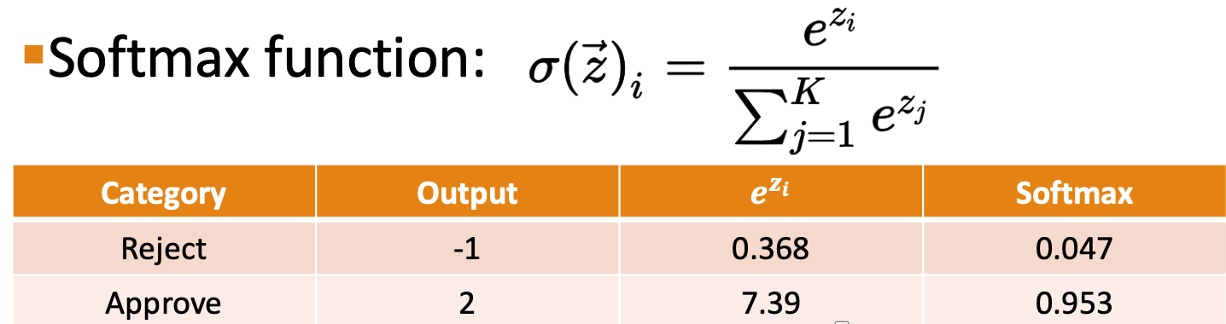
Artificial Neural Network
A network with 2 input nodes, 3 hidden nodes, and 2 output nodes.
Fundamental Building Block: Tensors
Neural network: a function describing how inputs are mapped to the outputs
Tensors refer to the generalization of vectors and matrices to an arbitrary number of dimensions
Transpose A Tensor
Transfer Tensor to GPU
Represent Tabular Data with Tensors
Tensor Element Types
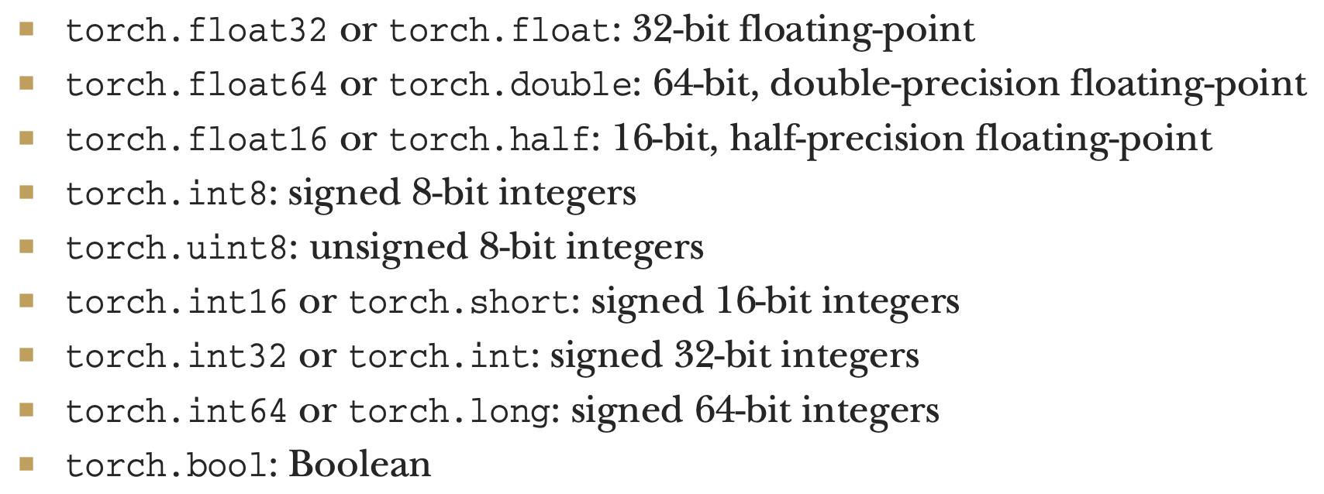
The default data type for tensors is 32-bit floating-point
3. Using a Neural Network to Fit the Data
Neural Network: Forward Pass
- Step 1: Model initialization: Randomly set initialized neural network
- Step 2: Feed forward: The model is fed input data
- Neural Network: Backward Pass
- Step 3: Calculate the error: How far is your model output from the actual value.
- Step 4: Compute gradient of the error: apply the chain rule to compute gradient
with respect to the parameters
- Step 5: Update the parameters: Update the parameters (weights and biases) until
the error becomes minimum.
The Learning Process
Forward pass
Given input data and initial values for the weights, the model is fed input data
Backward pass
A measure of the error is evaluated by comparing the outputs to the ground truth
The gradient of the error with respect to the parameters is computed using the chain rule
Optimize the parameter of the model: the value of the weights is then updated in the direction that leads to a decrease in the error.
The procedure is repeated until the error falls below an acceptable level.
The Learning Process
Backward pass: 1. A measure of the error is evaluated by comparing the outputs to the ground truth
Goal—minimize the error: Our optimization process should therefore aim at finding w and b so that the loss function is at a minimum (the predicted t_c is close to the actual t_c)
◦ We need to exactly define a measure of the error
◦ loss function—should be high if the error is high and should ideally be as low as possible for a perfect match
The Learning Process
A loss function (or cost function) is a function that computes a single numerical value that the learning process will attempt to minimize
The calculation of loss typically involves taking the difference between the model outputs and actual values
◦ Absolute error loss: |t_p – t_c| ◦ Squared error loss: (t_p – t_c)^2
Define the objective of learning
The Learning Process
Backward pass: 2. The gradient of the error with respect to the parameters is computed using the chain rule
We compute the individual derivatives of the loss with respect to each parameter
The gradient depends on both the loss function and model
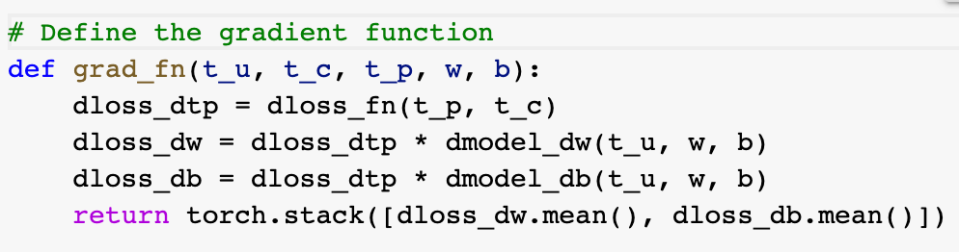
The Learning Process
Backward pass: 3. Optimize the parameter of the model: the value of the weights is then updated in the direction that leads to a decrease in the error.
Learning rate: The learning rate is a hyperparameter that controls how much to change the model in response to the estimated error each time the model weights are updated
The effect of learning rate §The effect of epoch
Generalization and Overfitting
Comparing the model performances on training and testing data
◦ Max depth = 1
Generalization and Overfitting
Comparing the model performances on training and testing data
◦ Max depth = 2
Generalization and Overfitting
Comparing the model performances on training and testing data
◦ Max depth = 10
Generalization and Overfitting
Causes for Overfitting:
Training data is not a good representation of testing (new) data
Insufficient training data
Noises in data: inconsistent class labels for the same values in feature set (input attributes)
Outliers in data: the number of samples with a given combination of class labels and feature values is small.
An algorithm’s inability to avoid overfitting noises/outliers or to train generalizable models via small amounts of training data
Complex model
Generalization and Overfitting
Avoidance of Overfitting §Data strategies
Secure sufficient data
Identify and handle potential outliers and noises
Evaluation strategies
Identifying overfitting: comparing the model performance on training
and testing data
◦ Avoid big gap between the training and testing accuracy
Model strategies
Select proper algorithm and manage model complexity
◦ Compare different algorithms
◦ Lower model complexity via method-specific parameters
4. Classification
- Classification
- Classify objects into a set of pre-specified classes (or categories) based on the values of relevant object variables (features).
- Why classification? Estimating/predicting the class or category of action to support time and cost-effective decision making.
- Classification
- Predictor: A predictor (or predictor variable) is a variable whose values will be used to predict the value of the target variable.
- Target variable: The target variable (or outcome variable) is the variable whose values are to be modeled and predicted by other variables.
- Classifier: an algorithm/classification model that implements classification (mapping input data to a category).
- Step 1: Kicked Vehicle Data
- Step 2: Data Preprocessing
- Dummy coding
- Dummy coding: convert categorical variables into numeric format ◦ Create dummy variables to replace the original categorical variable
◦ Dummy coding for a binary variable: gender
- Step 2: Data Preprocessing
- Split the data to training and testing sets
- Step 3: A Multi-Layer Neural Network
- Build a model with nn.Sequential
- 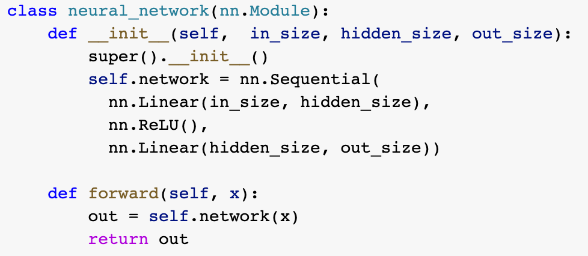
- Step 3: A Multi-Layer Neural Network
- Encode label to numeric
- Step 3: A Multi-Layer Neural Network
- Tensors, Tensor Dataset, and Data Loader
TensorDataset: wraps tensors to form a tensor dataset. It stores the
- samples and their corresponding labels.
- DataLoarder: wraps an iterable around the Dataset to enable easy access to the samples.
- ◦ Training with minibatches: The job of a data loader is to sample minibatches from a dataset, giving us the flexibility to choose from different sampling strategies.
- Batch size: batch size is a hyperparameter that defines the number of samples (data points) to work through before updating the internal model parameters
- Epoch: the number of epochs is a hyperparameter that defines the number times that the learning algorithm will work through the entire training dataset
- Step 3: A Multi-Layer Neural Network
- Define a complete training loop
- 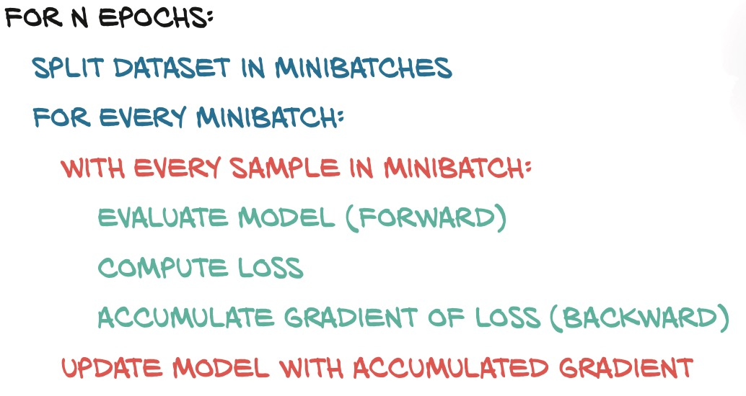
- Step 4: Evaluate Neural Network Model Performance
- Holdout Evaluation
Splitting method (percentage split)- divide into training and testing
- sets (e.g. 70%/30% or 2/3 to 1/3)
- ◦2 partitions, e.g.
70% and 30% in training and testing
- Train the model on the training data
- Training and testing data are not overlapped
- Step 4: Evaluate Neural Network Model Performance
- Understand the confusion matrix §Understand the meaning of evaluation metrics Model comparison
Cost-Benefit analysis
Overfitting issue
- Step 4: Evaluate Neural Network Model Performance
- Precision (No) = TP/(TP+FP)=2609/(2609+297)
Precision (Yes) = TN/(TN+FN) = 85/(85+9)
Recall (No) = TP/(TP+FN) = 2609/(2609 + 9)
Recall (Yes) = TN/(TN+FP) = 85/(85 + 297)
- 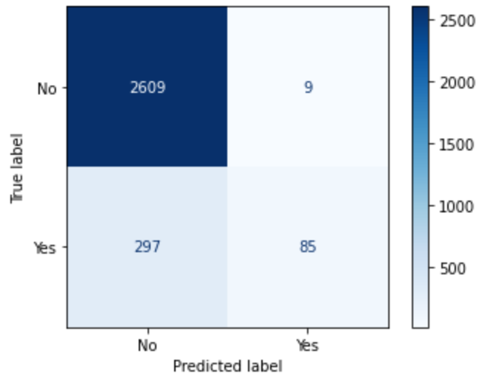
- 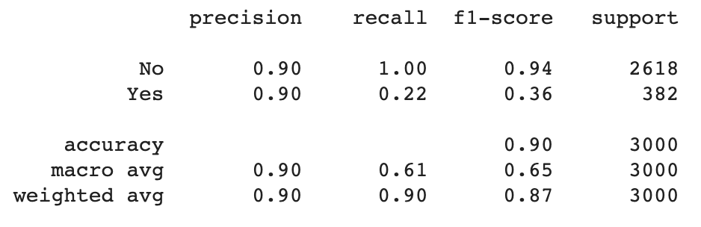
- Step 4: Evaluate Neural Network Model Performance
- Performance on the testing data:
- 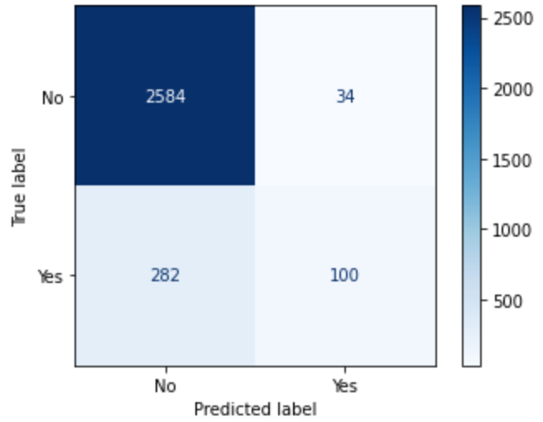
- 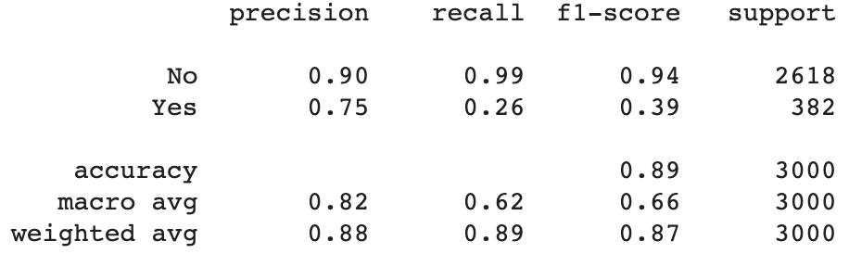
- How many cars are predicted as Not bad buy?
- How many bad buy cars are predicted as Not bad buy?
- How many bad buy cars are identified correctly by the naive bayes
model?
- If the naive bayes predicts a car as bad buy, what is the probability
that such prediction is correct?
- Does the naive bayes model have better performance on majority
(IsBadBuy = 'No') or minority class (IsBadBuy = 'Yes')?
Step 4: Evaluate Neural Network Model Performance: Model Comparison
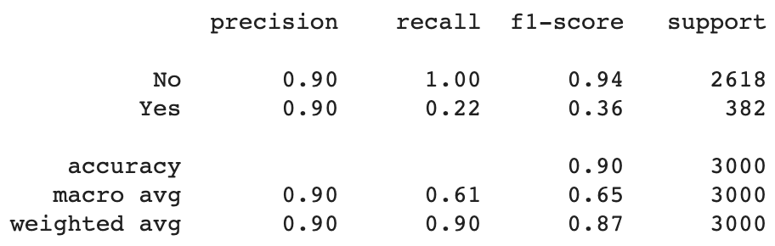
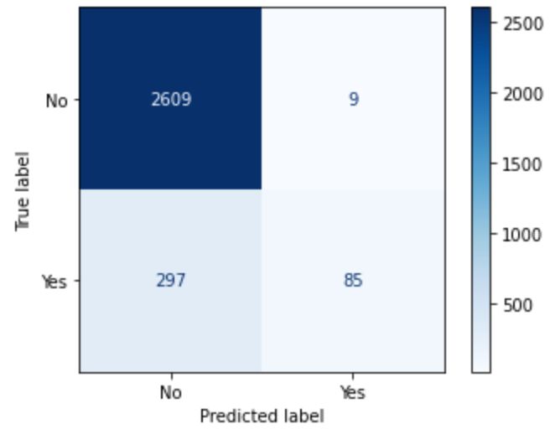
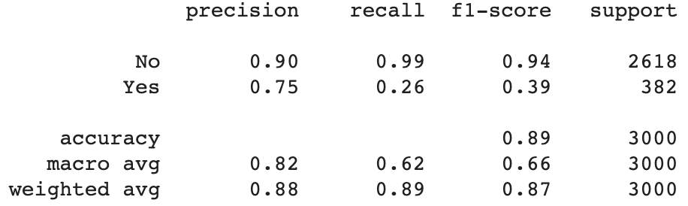
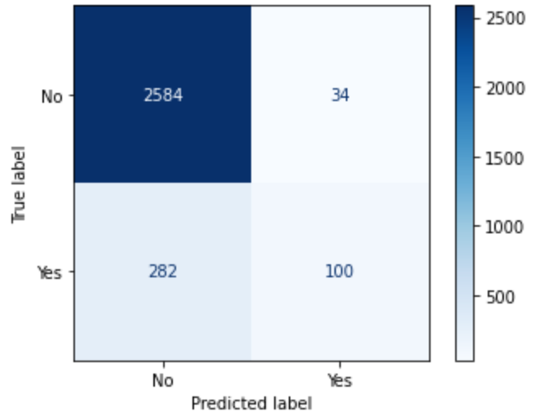
1. Compare the performance on the majority and minority class
2. Which model is better for identifying BAD BUY cars on testing data
3. Which model has higher confidence in predicting BAD BUY cars on testing data? 4. Which model has better performance on minority class (IsBadBuy = 'Yes')? why? 5. If you are a car dealership, which model you will use, and why?
Step 4: Evaluate Neural Network Model Performance: Cost-benefit analysis
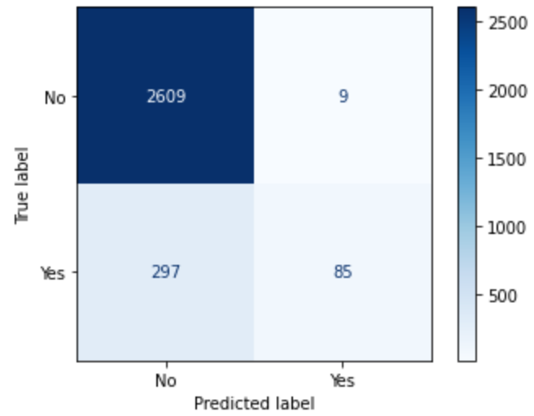
Assume the following costs / benefits:
• Costofbuyingabadcar:$2000
• Profitofpurchasingagoodcar:$300 • Opportunitycostofagoodcarthatis
missed: $300
Decision Tree model:
- Cost: 297 * 2000
- Profit: 2609 * 300
- Opportunity cost: 9 * 300
- Profit – Cost - Opportunity cost: 186,000
5. Machine Learning Basics – Numeric Prediction
•Numeric Prediction
•A numeric prediction problem is when the output variable is a real
value, such as “dollars” or “weight”.
Steps to Build A Multi-Layer Neural Network
Step 1: Medical Insurance Data
Step 2: Data Preprocessing
Step 3: Build a Neural Network on Training Data §Step 4: Evaluate Neural Network Model Performance
Evaluation Metrics for Numeric Prediction
Mean Absolute Error (MAE)
The mean absolute error (MAE) is a quantity used to measure how close
forecasts or predictions are to the eventual outcomes.
This is known as a scale-dependent accuracy measure and therefore cannot be used to make comparisons between series using different scales
Root Mean Squared Error (RMSE)
RMSE gives a relatively high weight to large errors. This means the RMSE
should be more useful when large errors are particularly undesirable.
Numeric Prediction vs Classification
• Differences between Classification and Numeric Prediction •Target variable
•Evaluation metrics

